knowledge
experience
achievements

Michał Szpor  ul. Kilińskiego 10; 41-800 Zabrze; Poland  phone: +48 665 226 166  e-mail: mike.szpor@gmail.com |  |  | Education: Master Degree in Economics  Post graduate: Project Management;  Experience: Lean Manufacturing  Operation and Production Management  Logistics, QM ;
Personal data: |  | date of birth: 13.02.69 nationality: polish married, 2 children
Professional experience:

2011 - currently | Delta Performance – freelance consultancy and training on lean management, for business and communities., production audits, large group facilitation, project management, creative thinking. See the Project Portfolio for details.
06.2008 - 12.2013 | Aperam Stainless Service And Solutions Poland Sp. z o.o. (former ArcelorMittal) – Production Manager - KPI resp. and reporting, consumables supply chain coordinator; establishing and maintaining suppliers relations, problem solving, negotiations. CAPEX acquisition and commissioning of production machinery. Quality assurance and control, implementation of lean management tools, continuous improvement, HSE coordination, resp. for ISO 14001.
12.2007 – 06.2008 | NT Industry Sp. z o.o. – (steel construction, welding and machinery co.) Logistics Manager – managing deliveries to Vestas project (DK), Delivery performance resp. Managing internal transportation and logistics, oversize project cargo coordination, maintain relations with transportation companies.
02.2005 – 12.2007 | C.Hartwig Gdynia S.A. (forwarding and logistics company) - Project Cargo Specialist; warehousing projects coordinator, Eltek Norway (Drammen) project manager; hub management, worldwide expedition and forwarding.
01.2004 – 01.2005 | Judith Hearn Agency – UK, HGV truck driver, recruitment and supervision of Polish drivers
09.2000 – 02.2002 | Carrefour Polska Sp. z o.o. –accounting specialist, order dept. clerk, IT clerk.
01.1997 - 08.1999 | Gullfiber Polska Sp. z o.o. (currently Isover Saint-Gobain)- assistant to financial manager,  assistant to the management board.
1993 - 1995 | Self-development program – UK ; Denmark; India – student / volunteer at TVIND – developing aid in third world countries

Education:

2012 | WSB Chorzow - Project Management - Postgraduate study
11.2002 | GWSH Katowice – Master degree in Management and Marketing;
1996 - 1999 | GWSH Katowice – BBA degree in Production Management.
Training and courses:

2013 | Trainers course (business coaching course) - by Trener Sukcesu; Kraków
2010 | Lean Game – 5S; KaiZen; SMED and other elements of Lean Manufacturing – by PCP
2006 | Management Training by ODiTK Gdynia
1994 | The Cambridge University, First Certificate in English - place of entry, Guildford, UK
1992 | HGV Class 1 driving licence
1983 - 1987 | Secondary education; machinery building and maintenance; technical drawings, welding and machining
Skills:

Foreign languages | English - fluent written and spoken; business and technical language; simultaneous translation skills, German and Russian - basic level; Polish - mother tongue
Computer skills | Good command of MS Office: Word, Excel, PowerPoint, Access, Outlook; Internet; knowledge of accounting software; administration of Windows NT; AS 400; Lotus, iMindMap
Experience & achievements | Working in international environment, Management experience, SMED, KAIZEN & TPM implementation. Positive influence on KPI; Reduction of consumables costs; machining and welding experience, over 15 years of experience in multinational corporation; business consultancy.

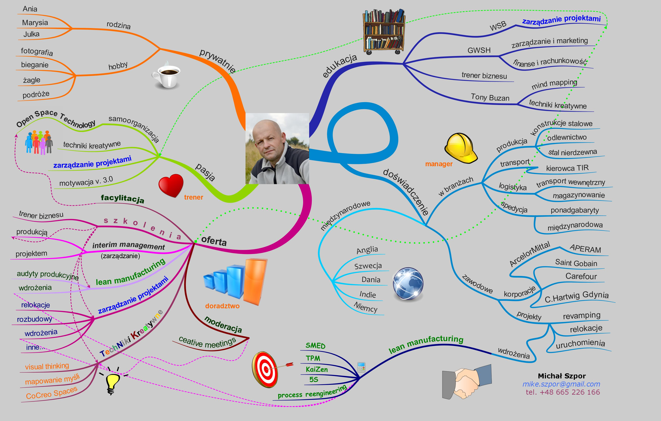

Project Portfolio

Michał Szpor
phone: +48 665 226 166
e-mail: mike.szpor@gmail.com

Scope: | Project management  Creative thinking  Large group facilitation  Lean Manufacturing & Management
Date: | Project:
2008 – 2013 | ArcelorMittal Stainless Service Centre - 4 SMED implementation, tolling changeover improvement of 36% in 2 days workshops. 5S, Kaizen and other Lean Manufacturing tools implementation.
2011 - 2013 | ArcelorMittal Stainless Service Centre – Health and Safety. Fatality Prevention Standard implementation. Conducted number of international FPS cross audits.
01.2014 | Dobrowianka (Danone group) – SMED workshop and production audit.
02.2014 | “Fuzja Możliwości, Synergia Działań” – Originator and organising of Open Space conference at Technopark Gliwice. Enhancing entrepreneurship for academic incubator. Over 60 participants.
03.2014 | Run Chłodnia – food processing. Freelance Lean Management production audit and consultancy.
03.2014 | Lidan Marine - (offshore equipment supply) Freelance Lean consultancy. Project in Mista (Poland) as customer production audit aiming for timely delivery planning and execution.
04-07.2014 | CITT Politechnika Śląska, Gliwice – innovation transfer process facilitation, free-of-charge project sampling
06.2014 – 01.2015 | Elektrocarbon Odlewy – project management for company relocation and operation, freelance management contract at the position of operational manager.
06.2014 | BlackRedWhite - production audit and consultancy for furniture manufacturing. Freelance consultancy
07.2014 | Wostal – Welding and steel construction. Lean ManufacturingpProduction workshop and re-engineering audit and design. Freelance consultancy
08.2014 | Folmag – marketing strategy workshop
11.2014 | OBDS – creative workshop for Christian community
11.2014 – 02.2015 | APERAM Stainless Service and Solution – Slitting line revamping. Project Management
03.2015 | APERAM Stainless Service and Solution – Germany to Poland blanking line relocation project coordination
04.2015 | “Zabrzański Rozrusznik” – 1st OST for local community, conference in Zabrze for participatory budget. Originator and facilitator.
04.2015 | Stomil Poznań – Lean Management production audit, snap-shot survey. Freelance consultancy.
05.2015 | Fajna Spółdzielnia Socjalna – 1st Social Enterprise Day; OST conference facilitator.
05.2015 | VII Lean Camp, Instytut Doskonalenia Produkcji, Lean size XL, speaker and facilitator of OST conference. 80 participants.
06.2015 | GSU inter-work (job agency) - Strategy planning workshop
08.2015 | Sektor3 Wrocław – MindMapping workshop, Project Management training for NGO (aktywny senior).
08 -10.2015 | Unexpected Unconference, Solar Winds – OST event for Agile programming. Consultancy and facilitation team member. 90 participants.
10.2015 | Cohabitat Fundation – OST conference for project leaders. Facilitation team member.
10.2015 - currently | Fundacja DO – founder and board member. Establishing NGO which is aiming at effective meetings trough large group facilitation, enhancing local communities’ dialog and participation.
07.2015 – 06.2017 | Interim management (operational manager) for Odlewy Precyzyjne Sp. K. Establishing new entity and production relocation.
10.2017 | Can Pack Glass, Aurangabad, India – Lean Management production audit on behalf of parent company.
- 10.2018 | Intermag Sp. z o.o. – Lean Management implementation – project leader
03 – 09.2018 | SKF Polska Sp. z o.o. – Pull production implementation project. SuperMarket implementation for forging plant. Project Management.
05-11.2018 | APTIVE – training on creative thinking and team work. Number of workshops for employees
- 09.2018 | ERKADO, Gościeradów – Lean Management implementation. Freelance consultancy. Team member.
10.2018 | APERAM Stainless Service and Solution Poland Sp. z o.o. – SMED workshop for slitting line

